Dsa lab 4

Lab task 1:
#include <iostream>
#include <string>
using namespace std;

struct Node {
string brand;
int units;
float price;
Node* next;
};

Node* head = NULL;

void addMobile() {
Node* newNode = new Node();

cout << "Enter Brand Name: ";
cin >> newNode->brand;

cout << "Enter Units in Stock: ";
cin >> newNode->units;

cout << "Enter Price: ";
cin >> newNode->price;

newNode->next = NULL;

if (head == NULL) {
head = newNode;
} else {
Node* temp = head;
while (temp->next != NULL) {
temp = temp->next;
}
temp->next = newNode;
}

cout << "Mobile Added Successfully!\n";
}

void deleteMobile() {
if (head == NULL) {
cout << "Inventory is empty.\n";
return;
}

string brandName;
cout << "Enter Brand Name to Delete: ";
cin >> brandName;

Node* temp = head;
Node* prev = NULL;

if (temp != NULL && temp->brand == brandName) {
head = temp->next;
delete temp;
cout << "Mobile Deleted Successfully!\n";
return;
}

while (temp != NULL && temp->brand != brandName) {
prev = temp;
temp = temp->next;
}

if (temp == NULL) {
cout << "Mobile Not Found.\n";
return;
}

prev->next = temp->next;
delete temp;
cout << "Mobile Deleted Successfully!\n";
}

void displayMobiles() {
if (head == NULL) {
cout << "Inventory is empty.\n";
return;
}

Node* temp = head;

cout << "\n--- Mobile Inventory ---\n";
while (temp != NULL) {
cout << "Brand: " << temp->brand << endl;
cout << "Units: " << temp->units << endl;
cout << "Price: " << temp->price << endl;
cout << "------------------------\n";
temp = temp->next;
}
}

int main() {
int choice;

do {
cout << "\n===== Mobile Store Inventory =====\n";
cout << "1. Add Mobile\n";
cout << "2. Delete Mobile\n";
cout << "3. Display Mobiles\n";
cout << "4. Exit\n";
cout << "Enter your choice: ";
cin >> choice;

switch (choice) {
case 1:
addMobile();
break;
case 2:
deleteMobile();
break;
case 3:
displayMobiles();
break;
case 4:
cout << "Exiting Program...\n";
break;
default:
cout << "Invalid Choice.\n";
}

} while (choice != 4);

return 0;
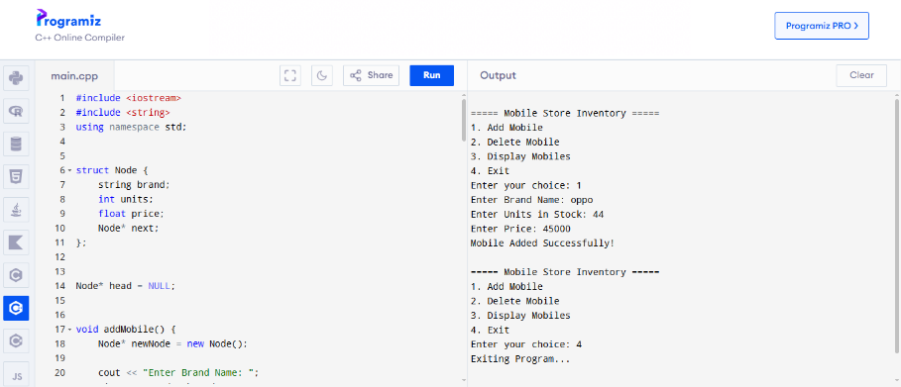
}

Lab task 2
#include <iostream>
#include <string>
using namespace std;

struct Node {
int userID;
string name;
int age;
string email;
Node* next;
};

Node* head = NULL;

void createProfile() {
Node* newNode = new Node();

cout << "Enter User ID: ";
cin >> newNode->userID;
cin.ignore();

cout << "Enter Name: ";
getline(cin, newNode->name);

cout << "Enter Age: ";
cin >> newNode->age;
cin.ignore();

cout << "Enter Email: ";
getline(cin, newNode->email);

newNode->next = NULL;

if (head == NULL) {
head = newNode;
} else {
Node* temp = head;
while (temp->next != NULL)
temp = temp->next;
temp->next = newNode;
}

cout << "Profile Created Successfully!\n";
}

Node* searchProfile(int id) {
Node* temp = head;
while (temp != NULL) {
if (temp->userID == id)
return temp;
temp = temp->next;
}
return NULL;
}

void updateProfile() {
int id;
cout << "Enter User ID to Update: ";
cin >> id;
cin.ignore();

Node* user = searchProfile(id);

if (user == NULL) {
cout << "Profile Not Found!\n";
return;
}

cout << "Enter New Name: ";
getline(cin, user->name);

cout << "Enter New Age: ";
cin >> user->age;
cin.ignore();

cout << "Enter New Email: ";
getline(cin, user->email);

cout << "Profile Updated Successfully!\n";
}

void deleteProfile() {
if (head == NULL) {
cout << "No Profiles Available.\n";
return;
}

int id;
cout << "Enter User ID to Delete: ";
cin >> id;

Node* temp = head;
Node* prev = NULL;

if (temp != NULL && temp->userID == id) {
head = temp->next;
delete temp;
cout << "Profile Deleted Successfully!\n";
return;
}

while (temp != NULL && temp->userID != id) {
prev = temp;
temp = temp->next;
}

if (temp == NULL) {
cout << "Profile Not Found!\n";
return;
}

prev->next = temp->next;
delete temp;

cout << "Profile Deleted Successfully!\n";
}

void viewProfiles() {
if (head == NULL) {
cout << "No Profiles Available.\n";
return;
}

Node* temp = head;
cout << "\n--- All User Profiles ---\n";

while (temp != NULL) {
cout << "User ID: " << temp->userID << endl;
cout << "Name: " << temp->name << endl;
cout << "Age: " << temp->age << endl;
cout << "Email: " << temp->email << endl;
cout << "--------------------------\n";
temp = temp->next;
}
}

int main() {
int choice;

do {
cout << "\n===== Social Media Profile Management =====\n";
cout << "1. Create Profile\n";
cout << "2. Update Profile\n";
cout << "3. Delete Profile\n";
cout << "4. Search Profile\n";
cout << "5. View All Profiles\n";
cout << "6. Exit\n";
cout << "Enter Choice: ";
cin >> choice;

switch (choice) {
case 1:
createProfile();
break;
case 2:
updateProfile();
break;
case 3:
deleteProfile();
break;
case 4: {
int id;
cout << "Enter User ID to Search: ";
cin >> id;
Node* user = searchProfile(id);
if (user != NULL) {
cout << "Profile Found!\n";
cout << "Name: " << user->name << endl;
cout << "Age: " << user->age << endl;
cout << "Email: " << user->email << endl;
} else {
cout << "Profile Not Found!\n";
}
break;
}
case 5:
viewProfiles();
break;
case 6:
cout << "Exiting Program...\n";
break;
default:
cout << "Invalid Choice!\n";
}

} while (choice != 6);

return 0;



